Abstract 已完成

Introduction 已完成

Description

Simple Reflex 何致远

Simple reflex agent is the simplest kind of agents. These agents select actions on the basis of the current percept, ignoring the rest of the percept history. For this paper, we are using a simple memory-less deterministic reflex agent as a vacuum cleaner which means it will select deterministic action for each condition, such as it turns right when it facing a wall. And the connection between the condition and action is called if-then rules. The if-then rules of our simple reflex agent are listed in follow:

If the room is dirty then suck up dirt

If not facing wall and clean then go forward

If facing wall and the room is clean then turn right by 90 degrees

If facing wall and at home then turn off

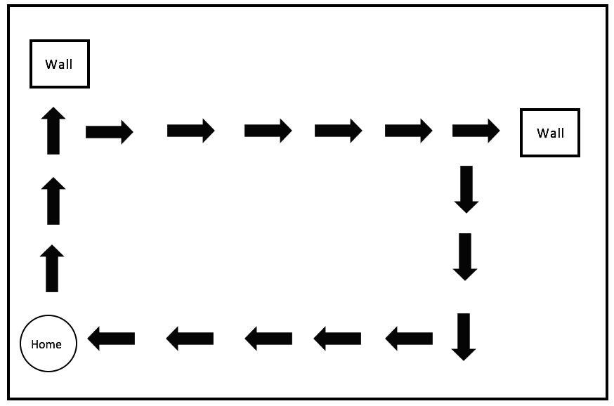

Random Reflex 何致远

Model based 林郑先，先简单写一下idea，再写if-then rules，最后加个图（以上simple reflex model为例）

Experimental setup 何致远

Result

何致远负责整理结果数据，设计表格，并统计。

林政先：

何致远：

1. What is the best possible performance achievable by the simple reflex agent in the two environments? What prevents it from achieving the goal of cleaning the room perfectly in each case?
2. How well does the random agent perform? Tune any parameters of the random agent to improve its performance. Give a table showing the number of actions it took to clean 90% of the room for each trial. What is the average of these numbers for the best 45 trials? What are the costs and benefits of randomness in agent design?
3. What did you learn from this experiment? Were you surprised by anything?